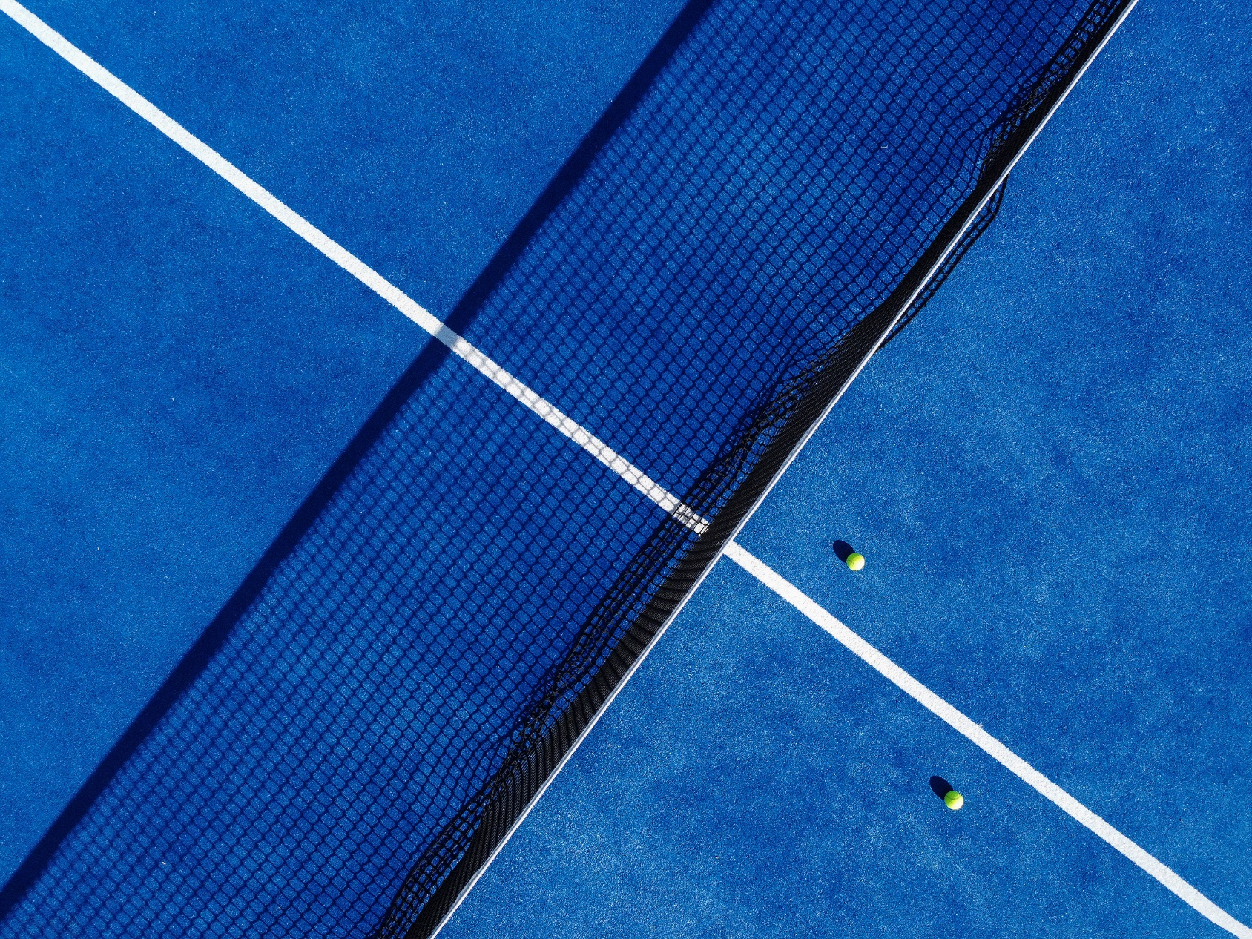

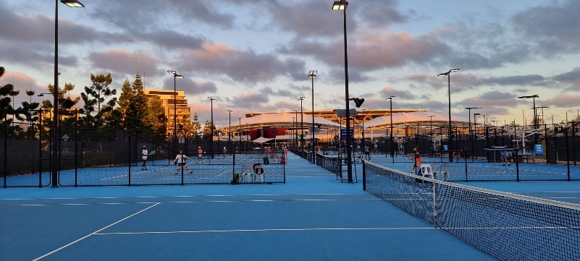

|  |  |
| --- | --- |
| **CLIENT:** | Brisbane Tennis Centre |
| **DURATION:** | November 2023 – December 2023 |
| **SURFACE:** | GreenSet |
| The Brisbane International Tennis Tournament is a prestigious Australian tennis event that attracts the best tennis players from around the World.  To ensure the best playing conditions for the athletes, the tournament organisers decided to resurface all 17 Hard Courts, including the main Pat Rafter Areana. The resurfacing project involved using the selected tournament surface GreenSet in a two-toned design of True Blue and Velocity Blue.  This task was complete by our dedicated team at Premier Sports and Leisure, who worked day and night, over six weeks to complete these works.  Overall, this was an amazing project for Premier Sports and Leisure to be apart of, and we wish all the players best of luck with their games this Tournament. | |

