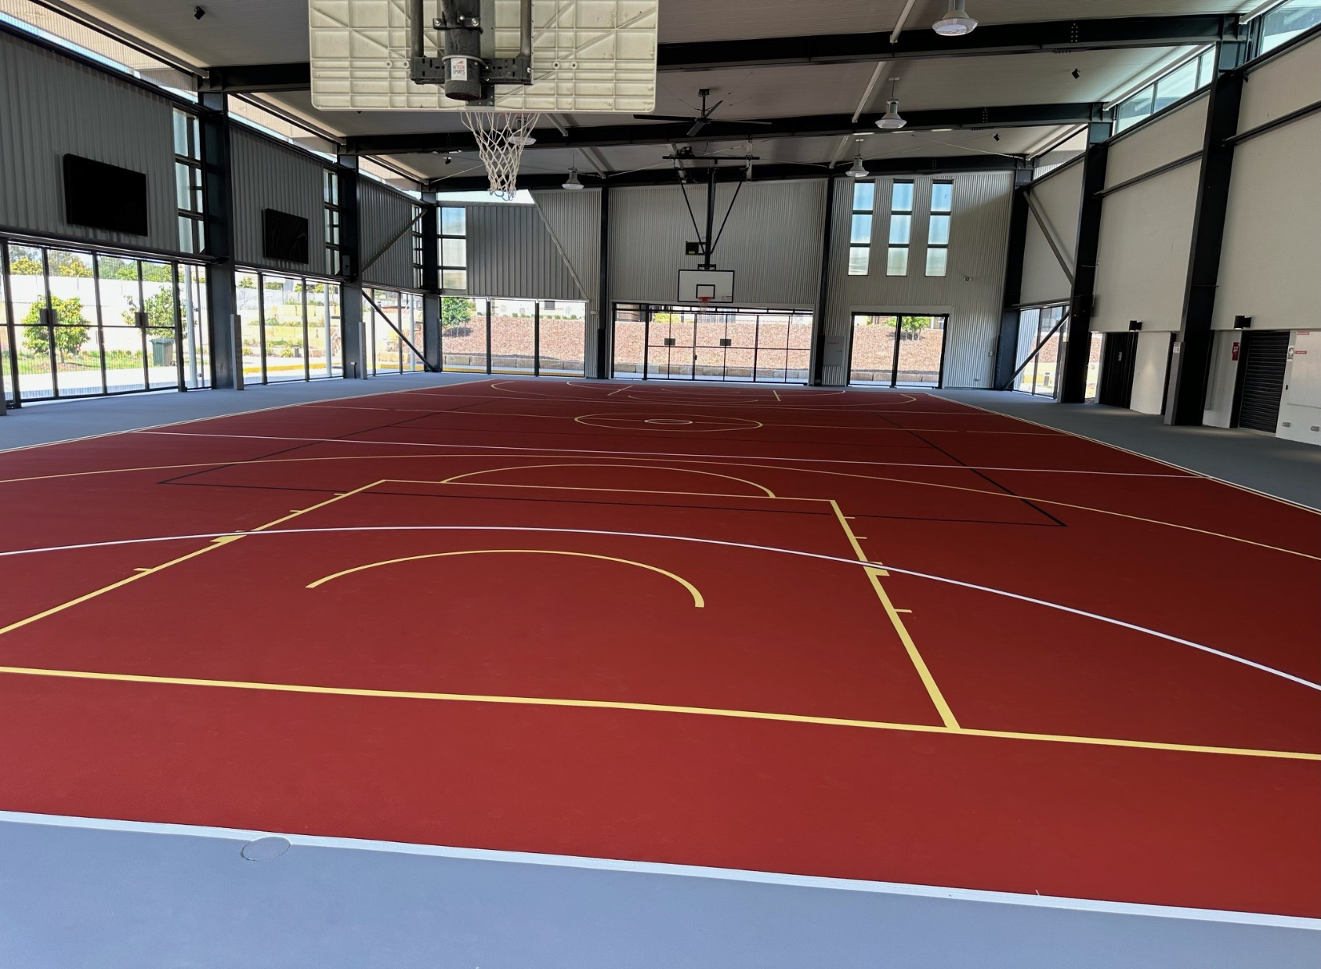

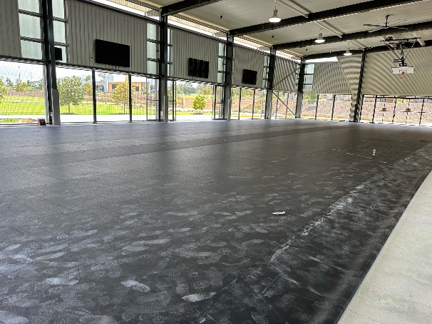

|  |  |
| --- | --- |
| **CLIENT:** | Sophia College (Plainland) |
| **DURATION:** | 3 Weeks |
| **SURFACE:** | Rebound HSA Cushioned Acrylic Surface |
| Premier Sports and Leisure, a leading sports surfacing and construction company, was contacted by Sophia College to replace their damaged sports court surface. The client wanted a durable and cushioned sports surface in their school colours, Terracotta and Mid-Grey. Premier accepted the challenge and successfully complete the project, providing the school was a state-of-the-are sports court.  Premiers team completing this by firstly removing the existing damaged court surface, followed by base works that was completed meticulously, as this is a crucial step to ensure a clean and sound base for the new court. The team then worked diligently day by day, following a step-by-step process to install the new cushioned sports court, as per manufactures specifications.  The client was extremely impressed with Premier’s work and the final result. Sophia College now has a new sports court that not only enhanced the school’s appearance but also provided a comfortable and safe playing surface for staff and students. | |

