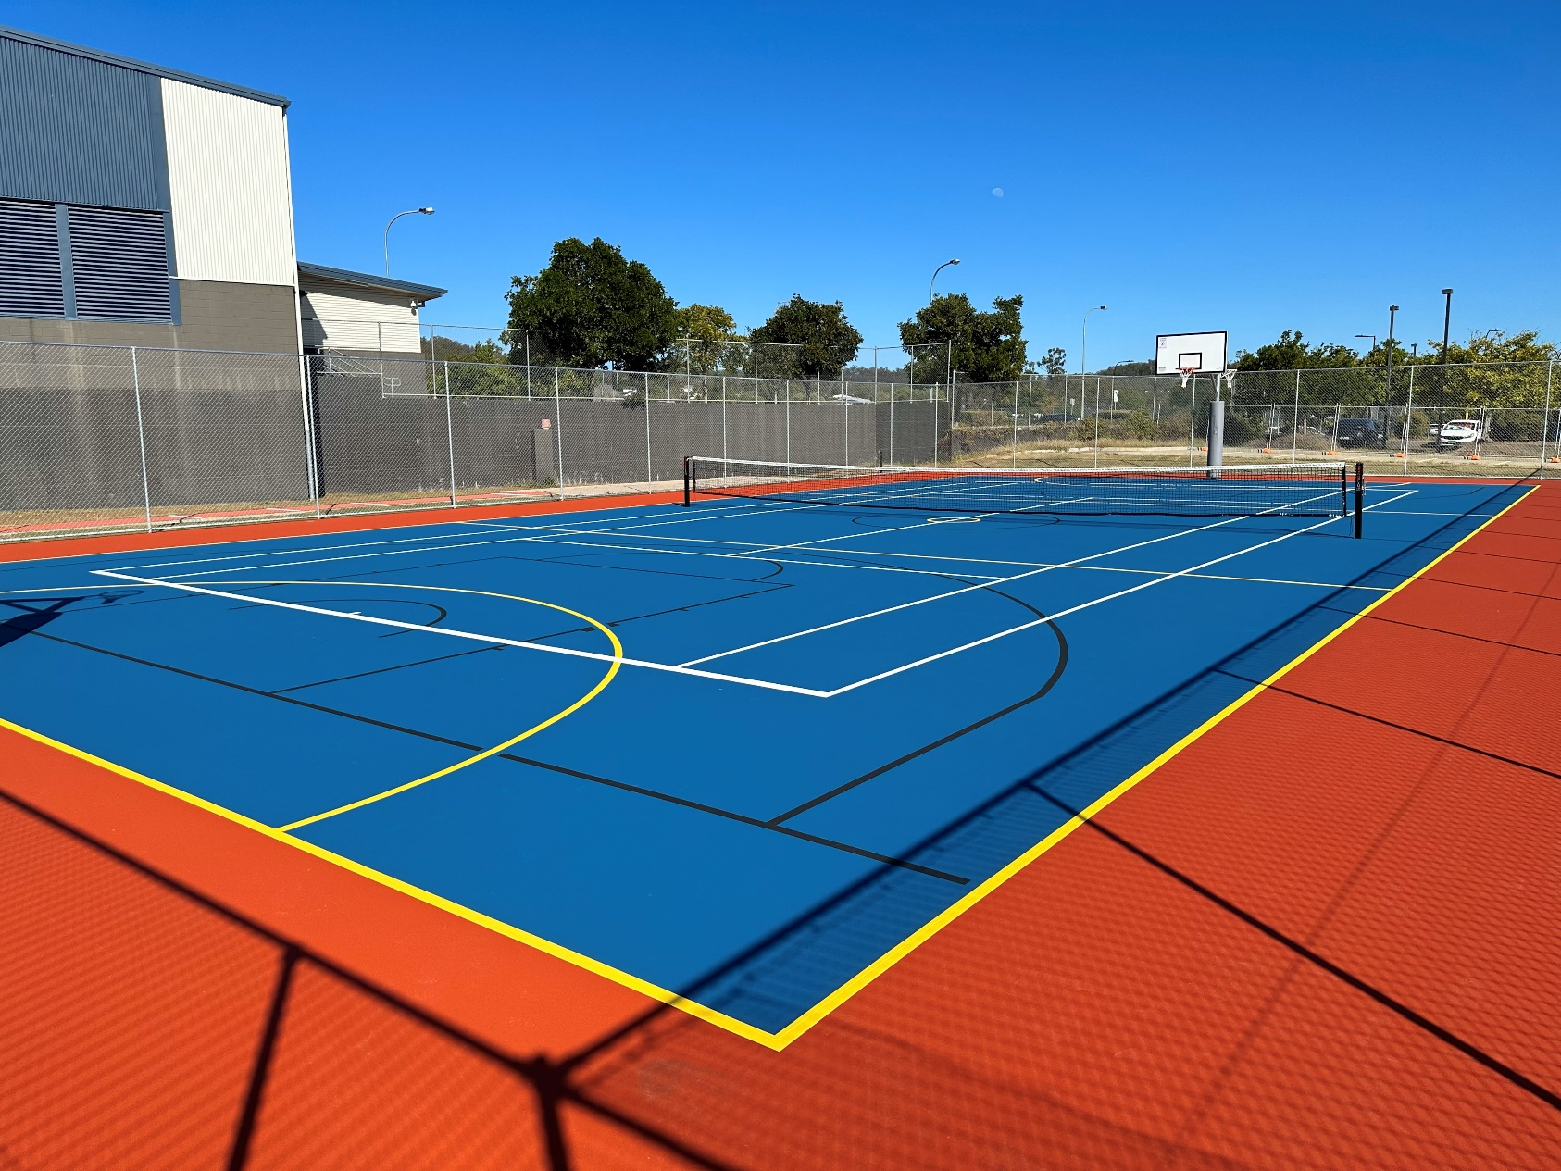

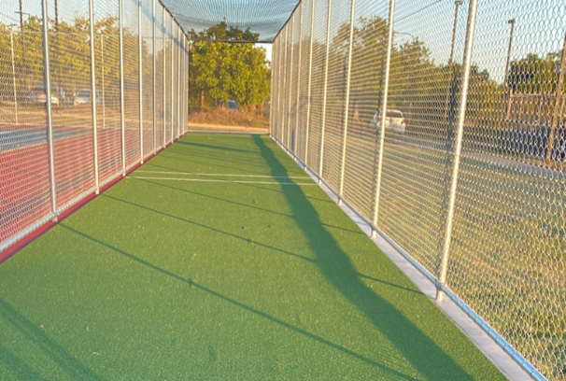

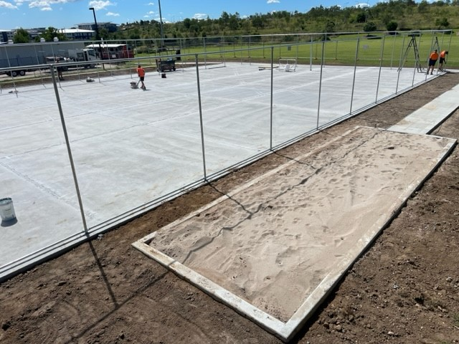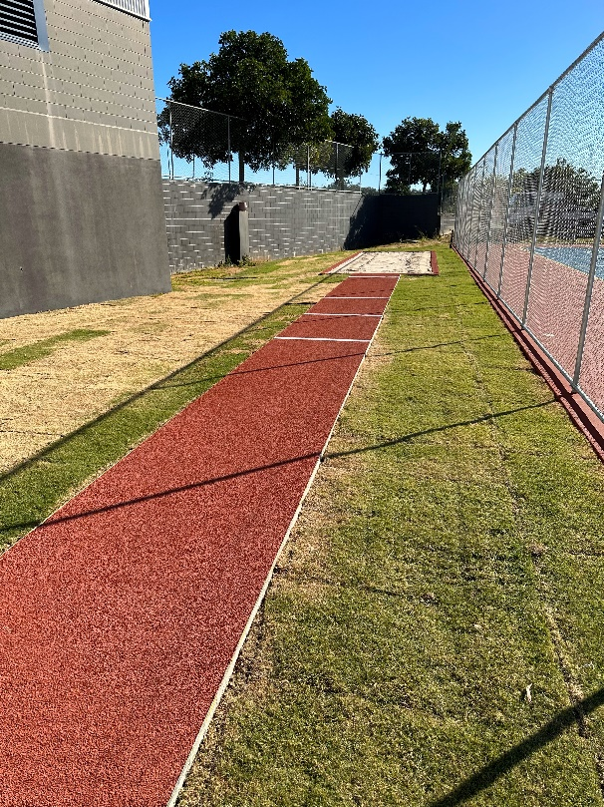

|  |  |
| --- | --- |
| **CLIENT:** | Springfield Central State School |
| **DURATION:** | 4 Months |
| **COURT SURFACE:** | Laykold Acrylic Hard Court |
| **CRICKET SURFACE:** | Urban Turf Cricket Synthetic Grass |
| **TRACK SURFACE:** | Spurtan BV |
| Premier Sports and Leisure was awarded the construction and surfacing of a new sporting precinct at Springfield Central State School. This project included a full-sized multipurpose court, a single lane practice cricket pitch and a two-lane long jump track with a landing pit.  These new facilities will provide the staff and students with a safe and modern space to engage in various sports activities. As always, our team worked diligently to ensure that the project was completed on site and to the highest standards, and we look forward to seeing the school community enjoy the new sporting precinct. | |