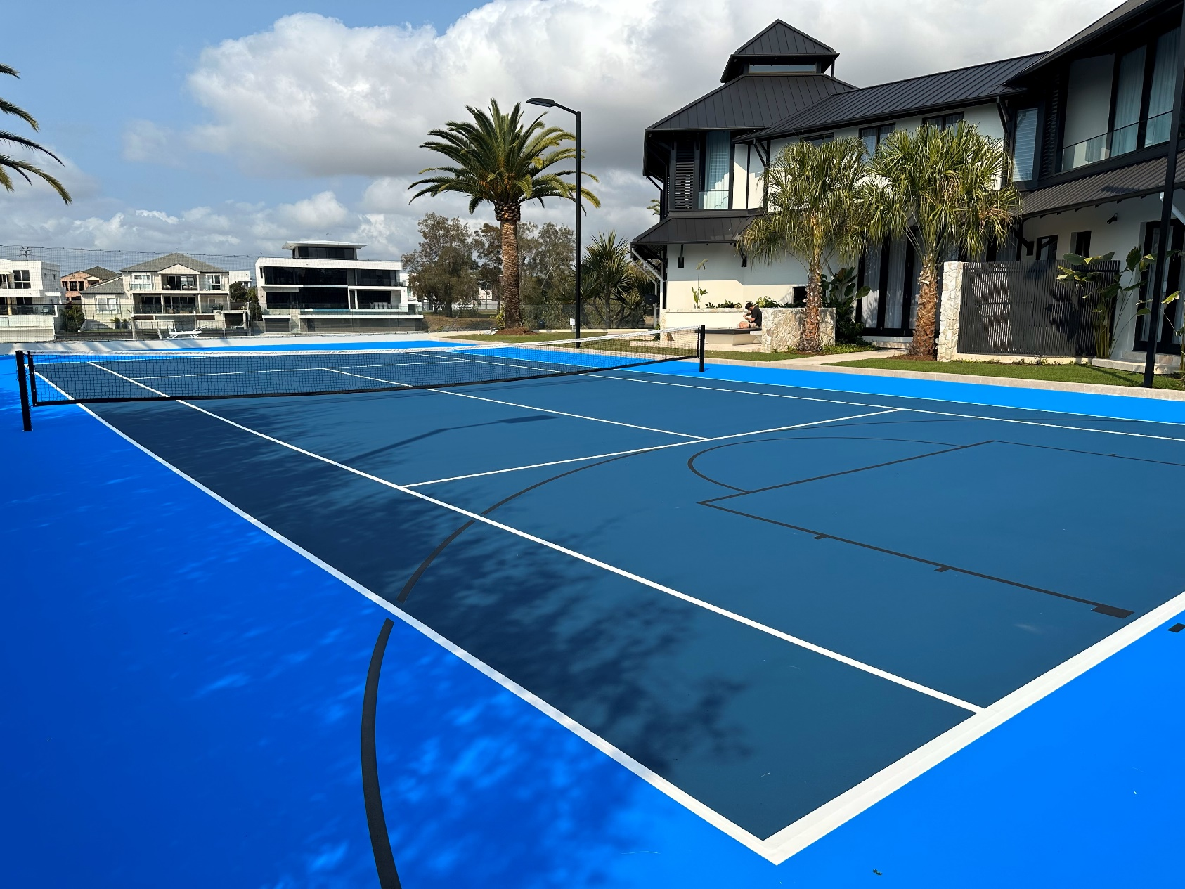

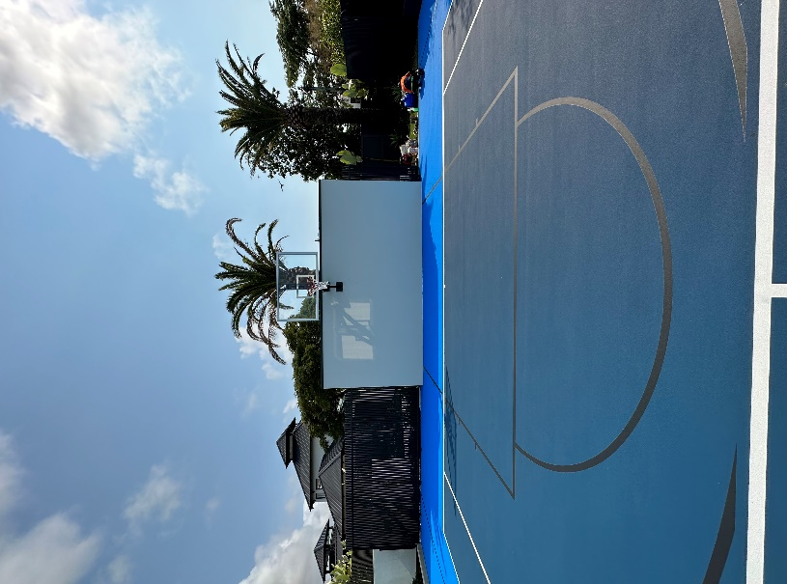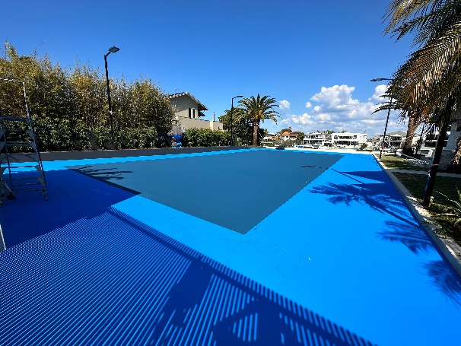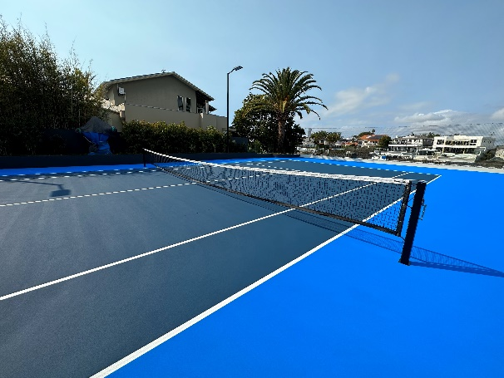

|  |  |
| --- | --- |
| **CLIENT:** | Clamroc Constructions - La Scala Project |
| **DURATION:** | 3 Weeks |
| **SURFACE:** | Laykold Acrylic Hard Court |
| Premier Sports and Leisure was approached by Clamroc Constructions with a specific request for a private sport court that would meet their clients’ unique needs. The clients wanted a facility that would allow them to play their favourite sports such as tennis and basketball from the comfort of their own home. Additionally, they wanted a design that would complement the current house and landscaping renovations underway.  Premier collaborated with Clamroc Constructions, a renowned construction company to bring the clients vision to life. This included providing a custom fabricated wall-mounted basketball system, court lighting, retractable court fencing, and a two-toned blue court surface.  This project showcases the expertise and dedication of both companies in delivering a high-quality and custom facility. The clients were overjoyed with the end result, and the sports court continues to be a source of enjoyment for them and their guests. | |